Assignment #1 Basic Visualization by Joshua Troup

1. How are machine sales in TN, NC and FL states? Are you selling a lot? If so, how is the

profit impacted?

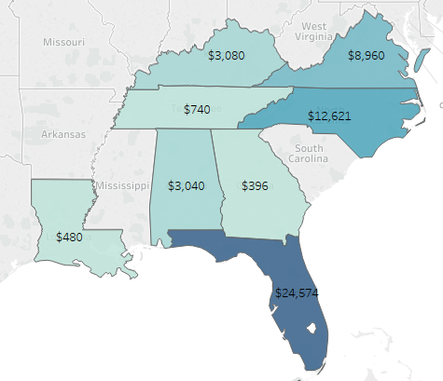

**Machine sales are the following:**

**Tennessee - $740**

**North Carolina - $12,621**

**Florida - $24,574**

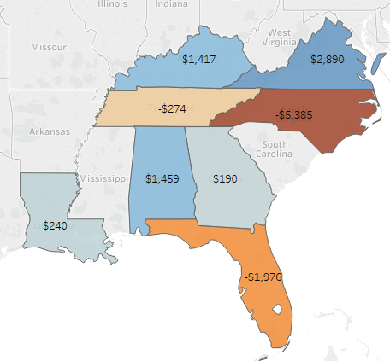

**The sales amount looks good alone but the outcome changes drastically when profit is added to the analysis. We can see Tennessee has a -$274 profit, North Carolina has a -$5,385 profit, and Florida with the astonishing high sales volume has a -$1,976 profit.**

2. What other factors might be contributing to these results? Are retailers in the south selling

products at a discount? (drag discount field into color on the marks card to

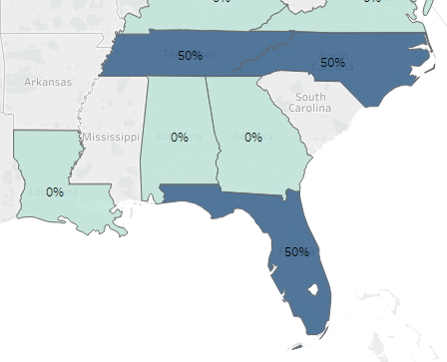

**The largest factor seems to be retailers are selling Machines at a discounted rate in these states resulting in a loss in profit. Tennessee, North Carolina, and Florida are the only three states selling at a 50% discount.**

3. What about table and binder sales? Comment.

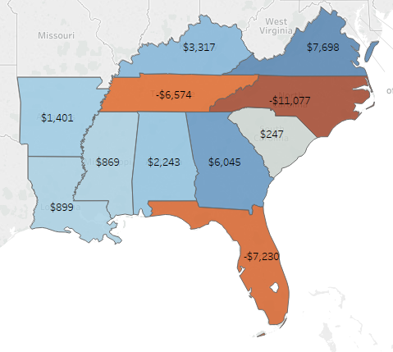

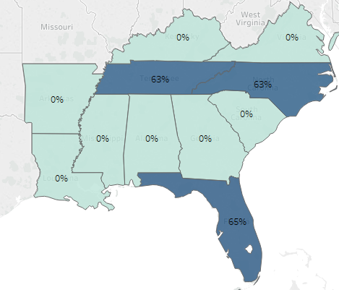

**Table, Binder, and Machine combined show a negative profit in the following states:**

**Tennessee -$6,574**

**North Carolina -$11,077**

**Florida -$7,230**

**The following discounts are given to the three items in these three states:**

**Tennessee 63%**

**North Carolina 63%**

**Florida 65%**

4. What happens to sales in Jacksonville, Miami, Burlington, Knoxville, and Memphis when

you remove either machines, tables, or binders?

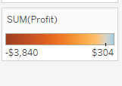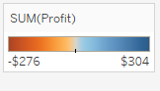

**The negative margin was -$3,840 in sales profit with machines, tables, and binders in five southern states. The negative margin was much less at -$276 when machines, tables, and binders were removed.**

5. What about bookcases? If you recall, bookcases were very unprofitable in other regions.

Digging into those regions might reveal additional solutions.

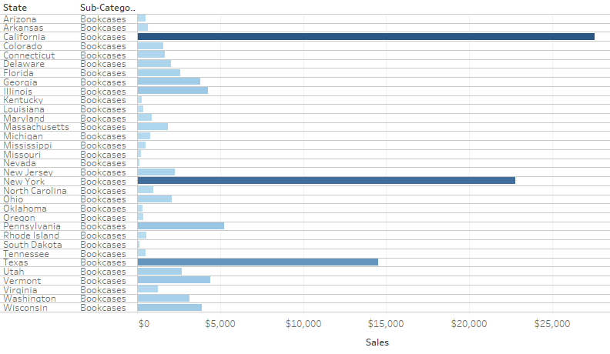

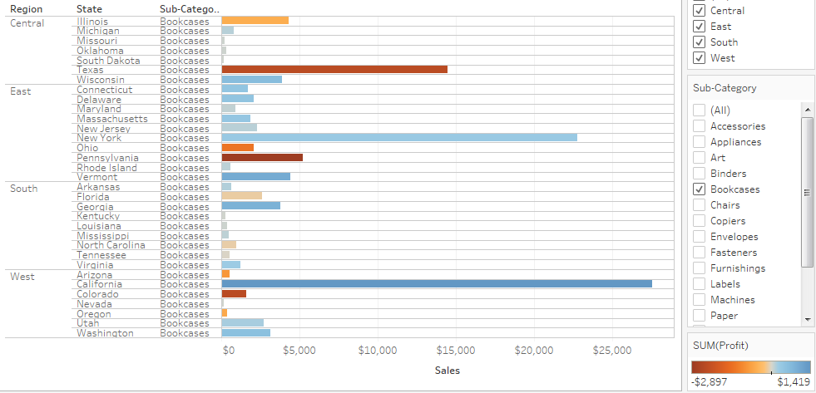

**Sales and profit of bookcases are strong in California and New York however Texas shows a negative profit of -$2,391. South region was the least profitable for machines, tables, and binders but seems to be one of the better performing regions for bookcases in respect to positive profit.**